**WORK BREAKDOWN STRUCTURE**

**AND SCHEDULE PROJECT EBOOK**

Dosen Pengampu: ARI EKO WARDOYO S.T., M.Kom.



**DISUSUN OLEH:**

**ARDHI HARRY SETIAWAN (2010651091)**

**BAYU KRISNA (2010651095)**

**FANKY NURILA IDOLAWAN (2010651119)**

**UNIVERSITAS MUHAMMDIYAH JEMBER**

**PRODI TEKNIK INFORMATIKA**

**2022**

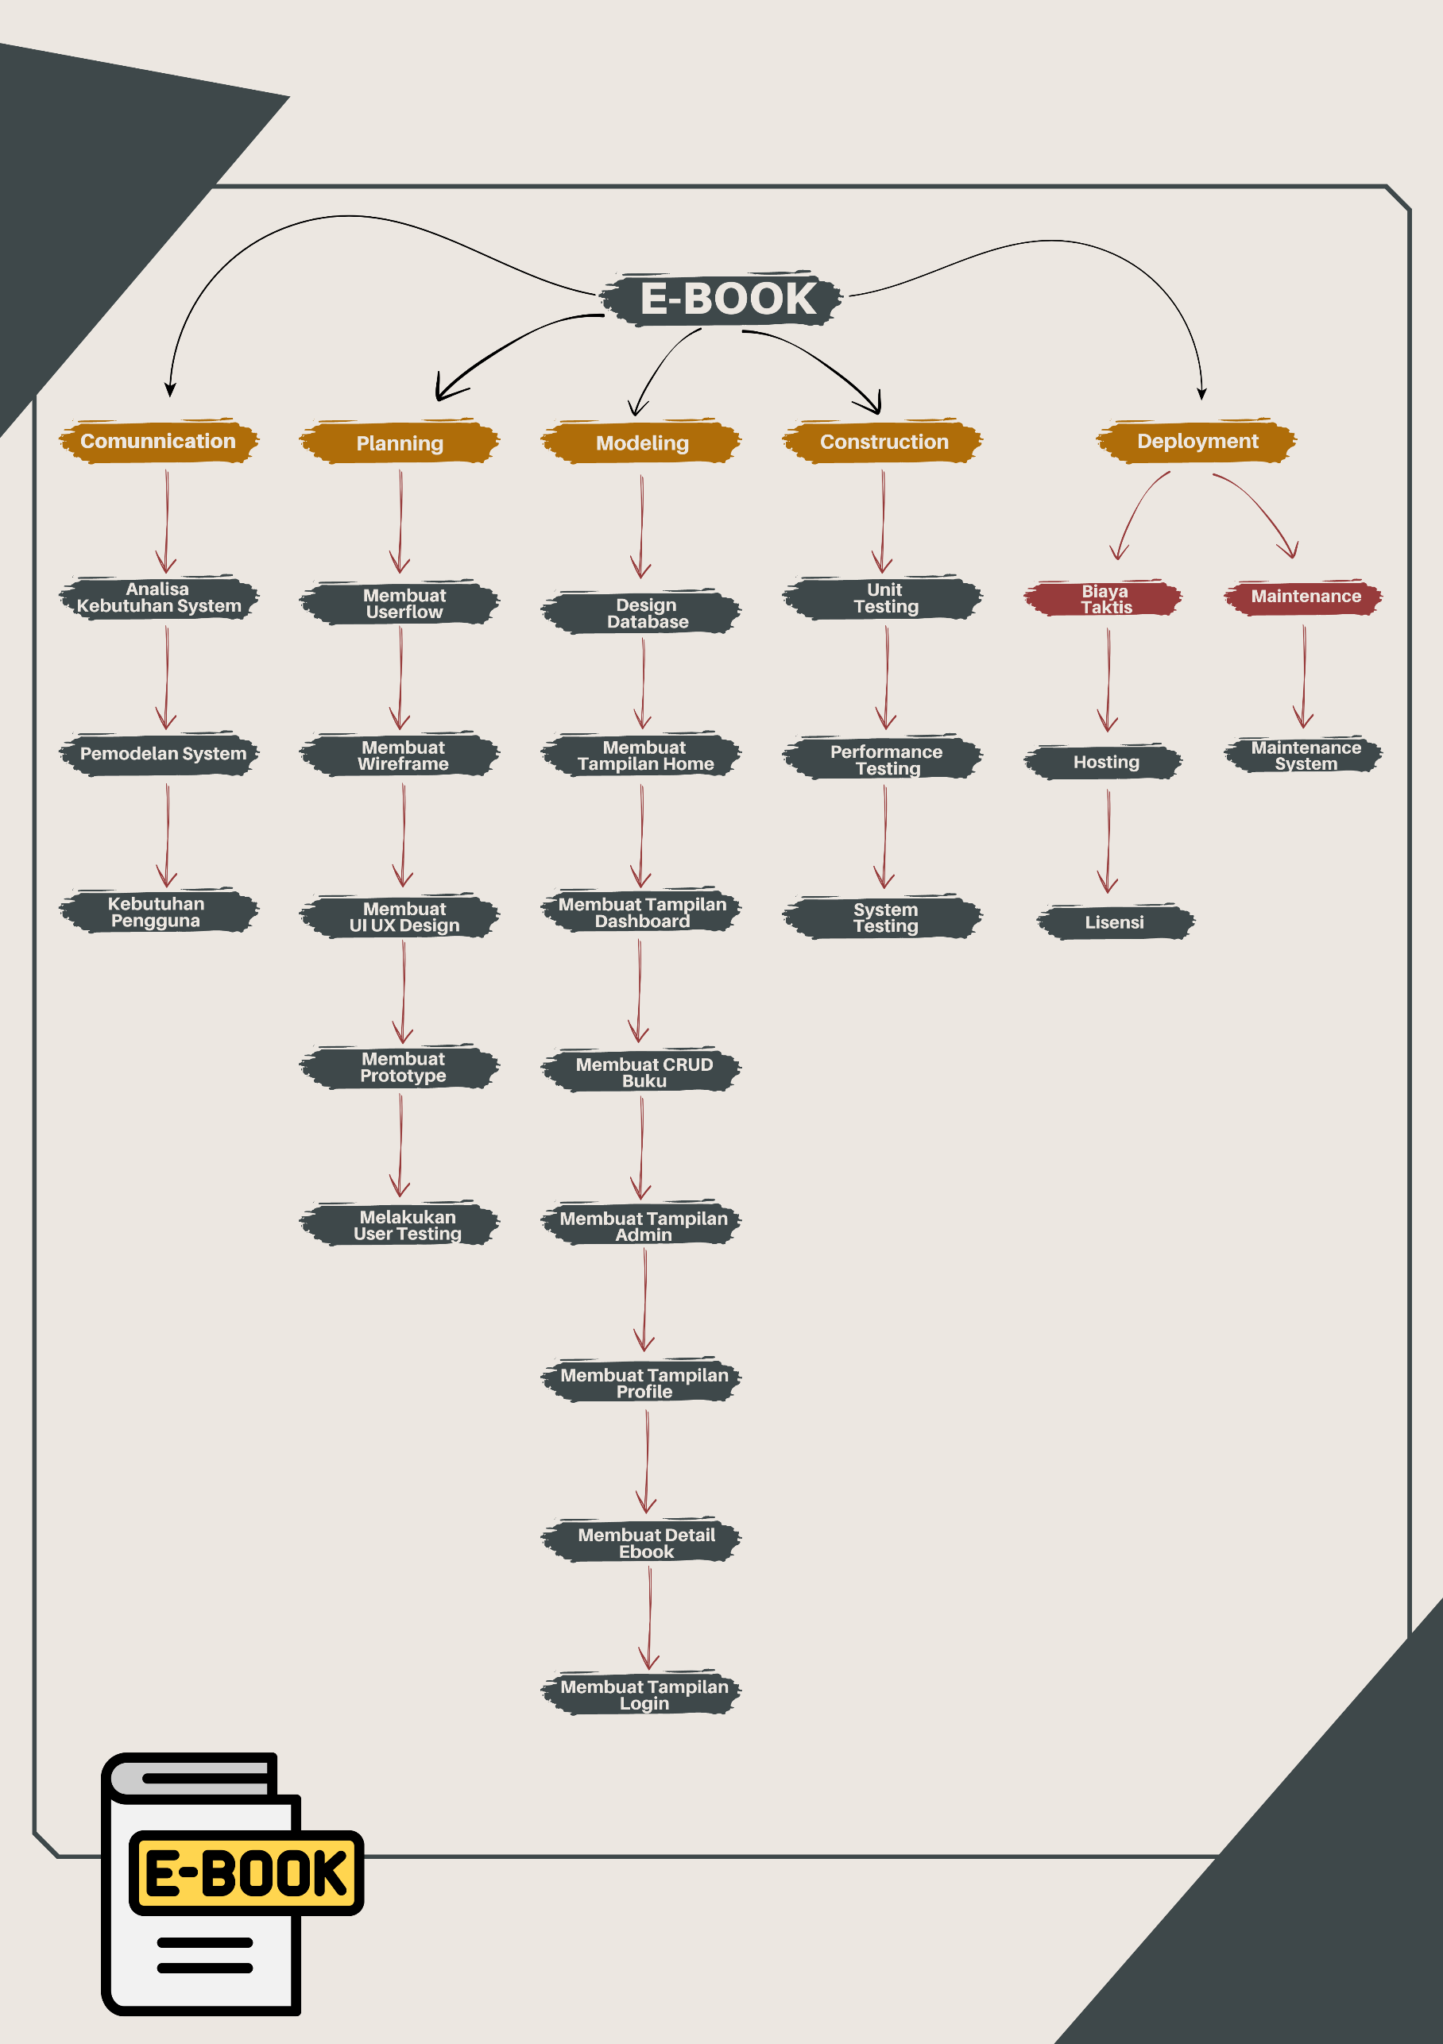

|  |  |  |  |  |  |  |
| --- | --- | --- | --- | --- | --- | --- |
| WBS | Nama | Durasi | Mulai | Selesai | Harga | Kerja |
| **1** | **E-BOOK** | **6,91d** | 05/06/2021 | 07/07/2021 | **Rp. 10.390.000** | **107h** |
| 1.1 | **Comunication** | **0.54d** | 05/06/2021 | 05/06/2021 | **Rp. 750.000** | **5h** |
| 1.1.1 | Analisa Kebutuhan System | 0,25d | 05/06/2021 | 05/06/2021 | Rp. 240.000 | 2h |
| 1.1.2 | Pemodelan System | 0,25d | 05/06/2021 | 05/06/2021 | Rp. 160.000 | 2h |
| 1.1.3 | Kebutuhan Pengguna | 0.04d | 05/06/2021 | 05/06/2021 | Rp. 350.000 | 1h |
| **1.2** | **Planing** | **1.58d** | 10/06/2021 | 10/06/2021 | **Rp. 1.105.000** | **38h** |
| 1.2.1 | Membuat Userflow | 1d | 11/06/2021 | 12/06/2021 | Rp. 170.000 | 24h |
| 1.2.2 | Membuat Wireframe | 0.21d | 12/06/2021 | 12/06/2021 | Rp. 320.000 | 5h |
| 1.2.3 | Membuat UI UX Design | 0.21d | 12/06/2021 | 12/06/2021 | Rp. 220.000 | 5h |
| 1.2.4 | Membuat Prototype | 0.12d | 12/06/2021 | 12/06/2021 | Rp. 215.000 | 3h |
| 1.2.5 | Melakukan User Testing | 0.04d | 12/06/2021 | 12/06/2021 | Rp. 180.000 | 1h |
| **1.3** | **Modeling** | **2.88d** | 15/06/2021 | 15/06/2021 | **Rp.2.435.000** | **42h** |
| 1.3.1 | Design Database | 0.5d | 16/06/2021 | 16/06/2021 | Rp. 1.000.000 | 12h |
| 1.3.2 | Membuat Tampilan Home | 0.04d | 17/06/2021 | 17/06/2021 | Rp. 145.000 | 1h |
| 1.3.3 | Membuat Tampilan Dashboard | 0.38d | 18/06/2021 | 18/06/2021 | Rp. 240.000 | 8h |
| 1.3.4 | Membuat CRUD Buku | 0.38d | 19/06/2021 | 19/06/2021 | Rp. 240.000 | 8h |
| 1.3.5 | Membuat Tampilan Admin | 0.21d | 20/06/2021 | 20/06/2021 | Rp. 165.000 | 5h |
| 1.3.6 | Membuat Tampilan Profile | 0.38d | 21/06/2021 | 21/06/2021 | Rp. 240.000 | 3h |
| 1.3.7 | Membuat Detail Ebook | 0.38d | 21/06/2021 | 21/06/2021 | Rp. 270.000 | 3h |
| 1.3.8 | Membuat Tampilan Login | 0.25d | 21/06/2021 | 21/06/2021 | Rp. 135.000 | 2h |
| **1.4** | **Construction** | **1.12d** | 25/06/2021 | 25/06/2021 | **Rp. 1.100.000** | **11h** |
| 1.4.1 | Unit Testing | 0.5d | 26/06/2021 | 26/06/2021 | Rp. 500.000 | 4h |
| 1.4.2 | Performance Testing | 0.12d | 27/06/2021 | 27/06/2021 | Rp. 250.000 | 3h |
| 1.4.3 | System Testing | 0.5d | 27/06/2021 | 27/06/2021 | Rp. 350.000 | 4h |
| **1.5** | **Deployment** | **0.79d** | 01/07/2021 | 01/07/2021 | **Rp. 5.000.000** | **11h** |
| **1.5.1** | **Biaya Taktis** | **0.54d** | 01/07/2021 | 01/07/2021 | **RP. 4.000.000** | **9h** |
| 1.5.1.1 | Hosting | 0.25d | 01/07/2021 | 01/07/2021 | Rp. 1.000.000 | 2h |
| 1.5.1.2 | Lisensi | 0.29d | 04/07/2021 | 04/07/2021 | Rp. 3.000.000 | 7h |
| **1.5.2** | **Maintenance** | **0.25d** | 07/07/2021 | 07/07/2021 | **Rp. 1.000.000** | **2h** |
| **1.5.2.1** | Maintenance System | 0.25d | 07/07/2021 | 07/07/2021 | Rp. 1.000.000 | 2h |